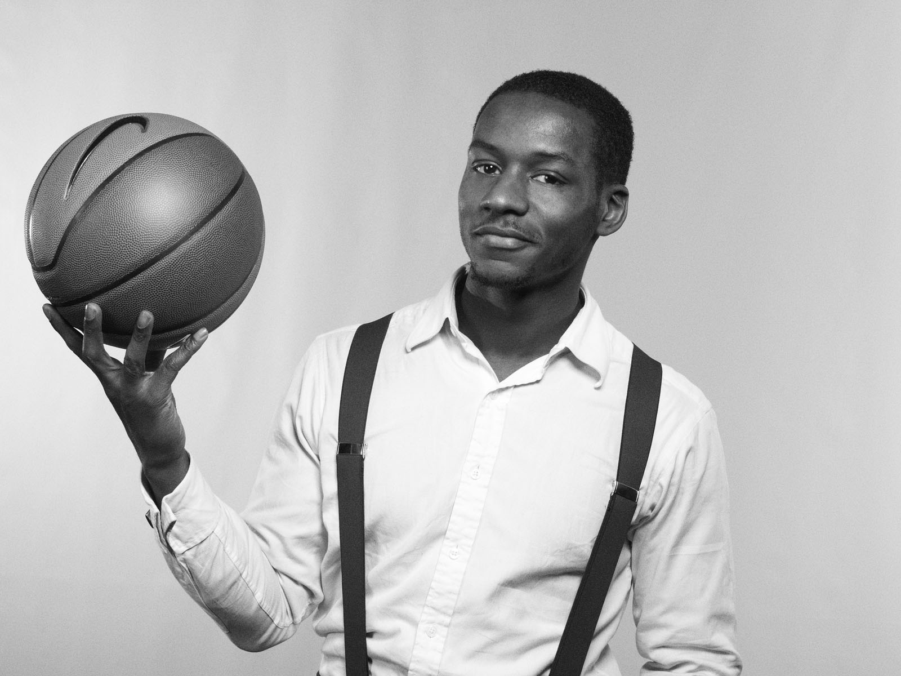
Dayo Okewale
Director
Dayo Okewale comes from a background Pro basketball, having played nationally, and internationally with experience totalling over 10 years, and basketball coaching experience of 5 years, a level 2 qualified basketball coach (England Basketball) soon to be level 3 accredited, an international sports trainer with experience working internationally with different cultures. He has a Business BA Honours Degree and great leadership experience.

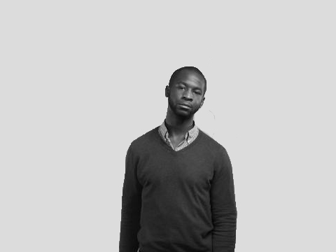

Adewale Adeyelu
Head of Operations
A very passionate person always making things happens. Ade is very zealous about youth and seeing young people achieve and stand out in their generation. Ade has outstanding liaising skills and is a natural leader. Over 10 years basketball experience, responsible for key sponsorships and new business. Previously worked with Charity from Boyhood to Manhood Foundation (FBMF). Founded of a project called Think Future a project that opens up business and career opportunities to students thinking about the next step after university. A Kingston University Business Enterprise award winner. Elected a trustee of the Volunteer Centre Westminster.

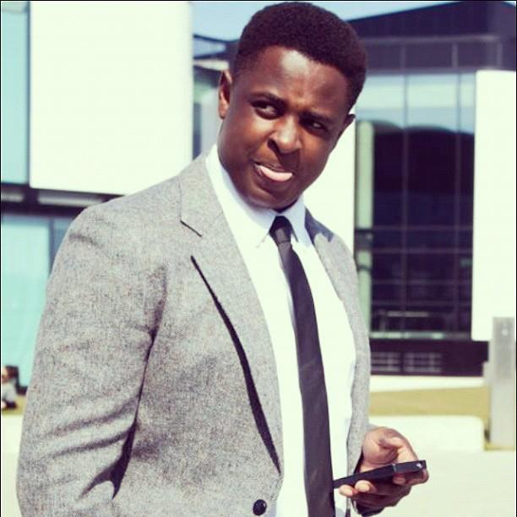

Mark Babatunde
Project Officer
Champion and lead for our current schools and college projects, Mark has always been a natural born leader, very active and competitive in sports. Young ambassador for Beyond Sport and part of the ‘Generation Ali’ team. He was in the top 10 under 17 in the UK at Shot Putt and has been to the English Schools Championship twice, and number one Shot Putter in his local borough seven years running. Mark Currently performs and teaches music, he goes into primary and secondary schools encouraging young people to be active and use their gifts and talents.

Israel Imwensii
Events Executive
Israel is an events executive. He is captain of his current basketball team and is part of the youth board for the college. Israel is a natural born leader he continues to encourage and inspire his generation. Born and raised coming out of east London Israel has overcome lot of gang and juvenile crime activity, he now gives back to his community with Who’s Got Game Basketball organization and is a well-conditioned athletic model to his environment. Israel is a Young ambassador for Beyond Sport and part of the ‘Generation Ali’ team.

